Learn to Program in JavaScript: Beginner to Pro

Introduction to JS

- JS is a lightweight programming language developed by Brendan Eich.

- It was first coined as “LiveScript” but when Netscape partnered with Sun microsystems, they changed it to “JavaScript”.

- ECMA (European Computer Manufacturers Association) standardize JS.

- It makes the websites responsive and usable since it is a programming language.

- JS code containing files can be linked to HTML or the code can be used with in a HTML file using “<script> </script>” tags.

REPL (Read Evaluate Print Loop)

REPL is a style that browser console uses. Basically, it loops - read, evaluate and print functions, so we can simultaneously give inputs and check outputs in the browser console. The below is an example of REPL style console which first reads from the user and evaluates it and prints it as undefined. After the termination process it again prompts the user.

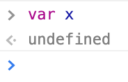

Flavor of JS

- JS is a scripting language in which set of statements is interpreted.

- It supports multi-programming paradigm (Multi-programming paradigm means mixture of different programming language that includes procedural (c), functional (Haskell) and OO programming (C++ & Java))

- JS functional programming treats functions as data so it can be passed as arguments and can also be returned while JS OOP is quite different it is not class based but prototype.

- It’s also a Dynamically Typed language whereas C, C++, Java are Statically Typed.

*Difference between class and prototype: Prototypes vs. Classes. The most important difference between class- and prototype-based inheritance is that a class defines a type which can be instantiated at runtime, whereas a prototype is itself an object instance.

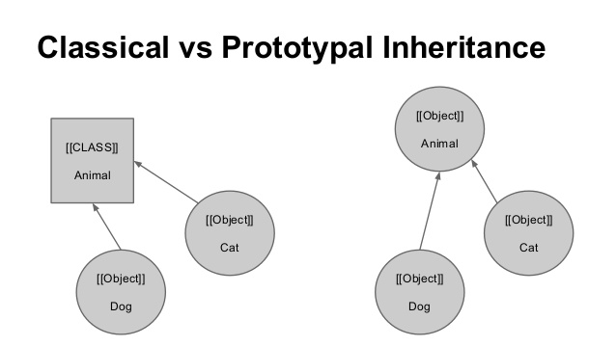

Data Types

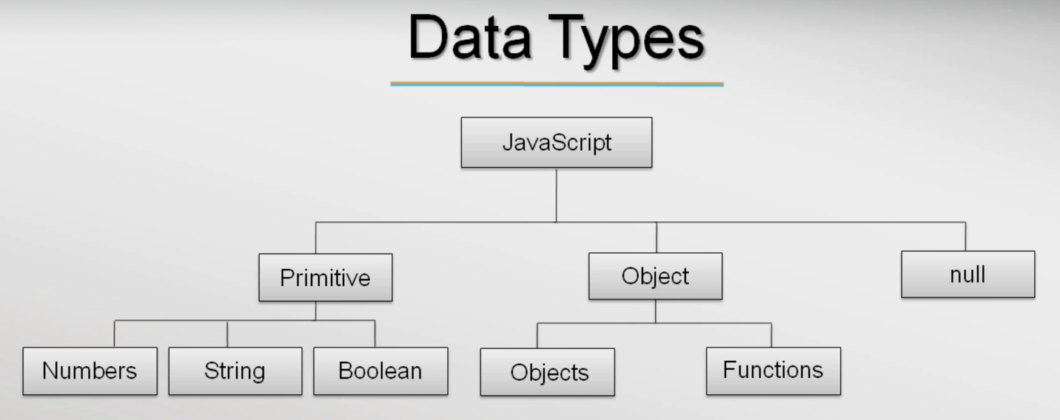

“var” is a keyword used to declare variables. Comparing this variable declaration with other programming languages we can clearly see that the type of variable is not mentioned during declaration that means JS support Dynamically Typed variables. Programming languages like C, C++ and JAVA are Statically Typed. Ex: var messages = “Hello”; - In this statement the browser console interprets dynamically and sets the type of variable when we assign value to it, if no value is given console simply takes undefined.

- JS has categorized its data types into 3 as follows,

— Primitive (Numbers, String, Boolean).

— Object (Apart from primitive types rest were considered objects even functions are considered as objects).

— Null (is a special type of object in JS that represents “no-objects”).

— Undefined is datatype, means a variable has been declared but has not yet been assigned a value

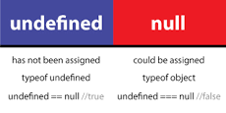

- Below shows the feature of dynamically typed variables,

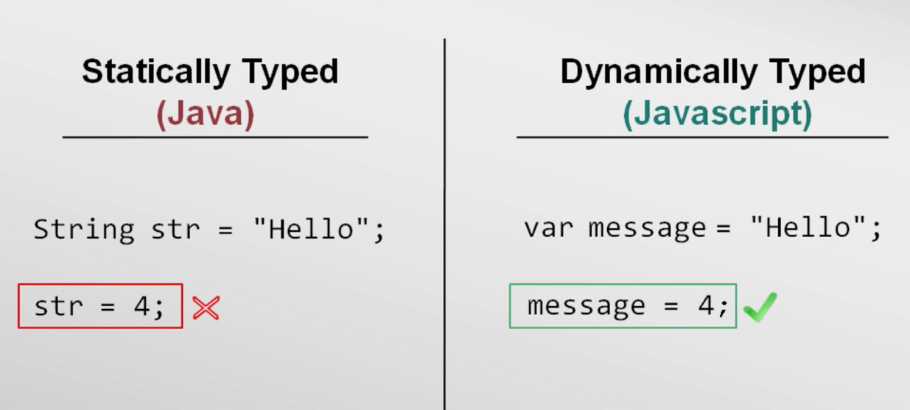

Ex: In the example below the variable msg can be assigned to different data without any warning or error. This is the beauty of Dynamically Typed language.

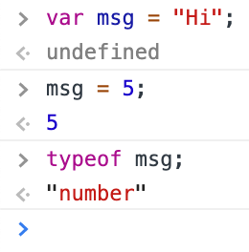

Primitive datatype

- String datatype

A string’s each character is stored as 16 bits of storage and UTF-16 format is implemented by default. We can use either double or single quotes for strings. Ex: var msg “Hello world” or ‘Hello World’ both are fine, where Hello world string is called string literal. JS has no inbuilt character data set, so string constrain is applied. To make use of “” or ‘’ quotes within a literal escape sequences (\) is applied. Different usage of escape sequence in JS is shown below,

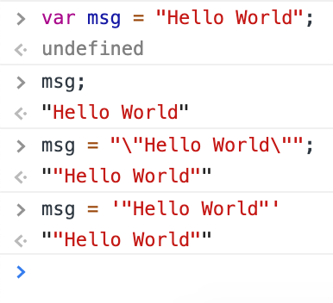

- Number datatype

JS doesn’t support int or float or any other type like other programming language. It’s just var here. Numbers are stored as 64-bit floating-point.

- Boolean datatype

False values in JS are undefined, null, 0, NaN (Not a Number) and “” (Empty string). The below code snippet explains the boolean functionality in JS

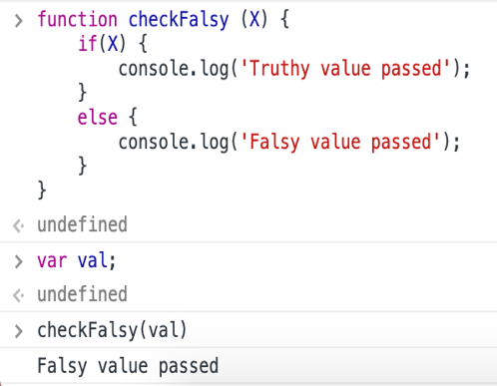

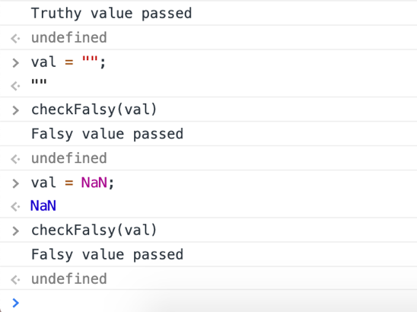

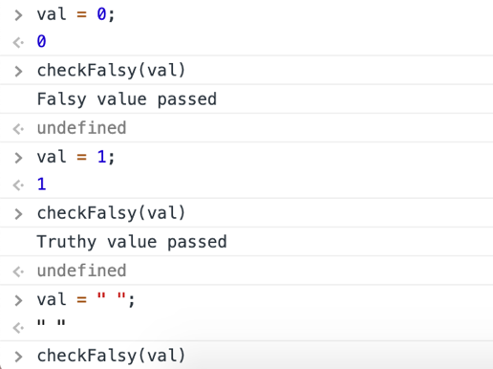

Comments

// 2 forward slashes for single line comment

/* Forward slash followed by a star char as start for multiline comment and these comments should be terminated by a star and a forward slash */

Operators

Basic operators in JS are as follows,

- Mathematical operators: +, -, *, / and %.

- Conditional operators: <, > <= and >=. Ex: “aa” < “ab” 🡪 prints true, since the JS interpreter checks this condition in alphabetic order.

- Equality operator: == and Inequality operator: !=. Ex: “2” == 2 🡪 prints true, the reason is to throw minimum errors during runtime thought they are different types. To check the type as well as the value === equality operator should be used, “2” === 2 🡪 prints false.

- String operators: typeof and instanceof.

Statement and Expressions

“var x = 5;” is a statement and is evaluated as undefined in a browser console because it is not returning any value, so it is undefined. While “x = 5;” is an expression but is evaluated as 5 that is console prints 5 since we assign the variable to a value.

// a statement that has no value

int x = 5;

// an expression...

x = 10;

// expression can be passed around

printf("%d\n", x = 15);

// (<https://stackoverflow.com/questions/3880093/var-variable-returns-undefined>)

Control flow statements (if-else, nested if-else, switch, while and do-while)

- “if” works with range of values.

- “switch” works with discrete values.

- “while” executes code block when the expression is true.

- “for” is a sugar-coated syntax of while.

- “break” and “continue” are keywords which we can use inside a looping statement. Just for our convenience.

Ex: break statement

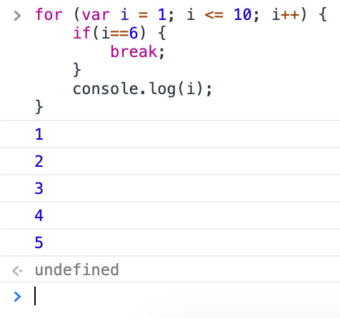

Ex: continue statement

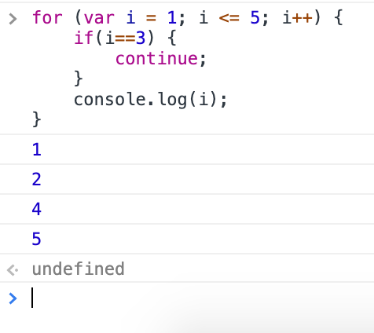

*It’s better to use if than switch because switch consecutively executes the cases after the desired expression. So that’s why break; statement is put below each cases.

*JS also supports multiple version of for loop one such version is for-in loop and its syntax 🡺 for (var x = I in book) { ... } // where book is an object or an array

Functions

- Since JS is a multi-programming paradigm, so it supports functional programming. Hence JS treats functions as first class citizens.

- Functions are treated as data or objects so they can be passed as arguments as well as a functions can also return a function. Ex: Callback function in filter, map and reduce functions are passed as arguments

- “function” is a keyword declares a function followed by its name.

- Function parameters don’t have type information same as var.

- Functions basically returns something, even JS function returns same as C++ or Java. But in C++ or Java when a function has nothing to return it returns void whereas JS returns undefined.

Ex: Function returns

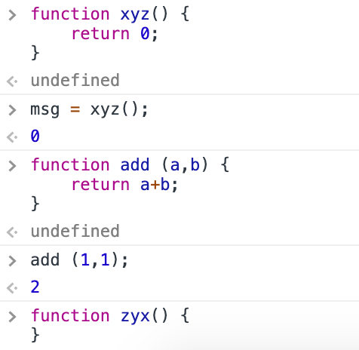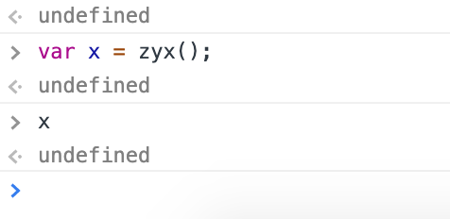

Block Scope & Function Scope

Block scope - A variable declared with in the curly braces, it could be in a function or in a control flow statement then that variable can only be accessed with in the curly braces.

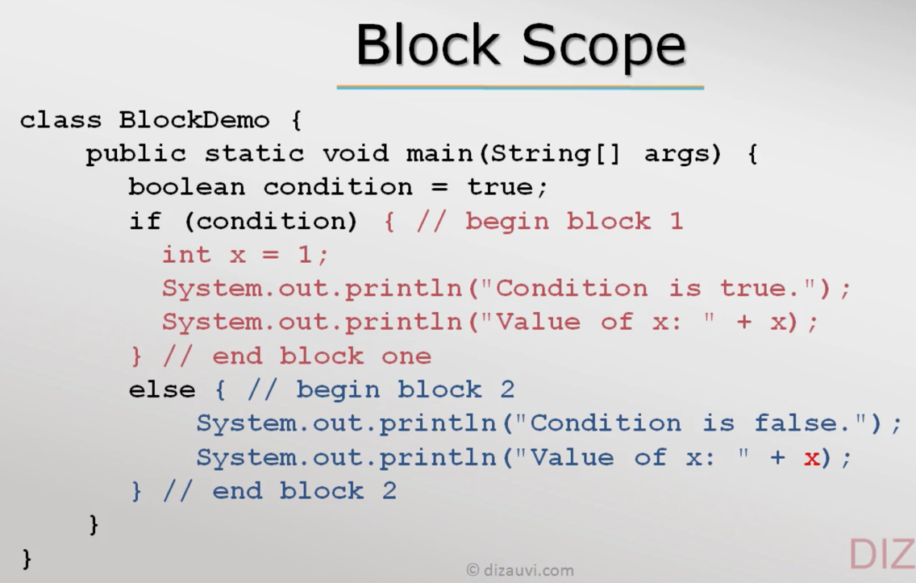

Function scope - A variable declared with in the function cannot be accessed outside.

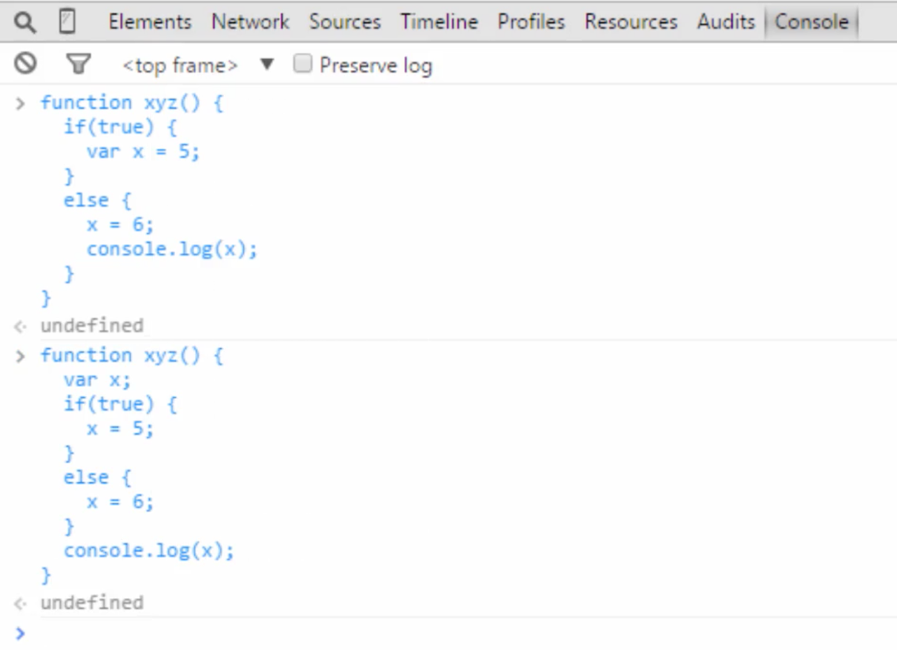

Type Conversion

Like other programming languages JS also supports type conversion but here it does some additional functions to avoid errors at run time.

Ex: Below the * and + are treated differently. Though “2” & “3” are strings they are considered numbers when we use * but when we use + the interpreter appends because + is defined to do the appending operation.

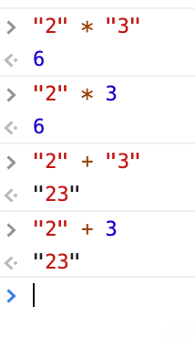

*The basic difference between type conversion and type casting is that the type conversion is made “automatically” by compiler whereas, type casting is to be “explicitly done” by the programmers. The two terms “type casting” and “type conversion” occur when there is a need to convert one data type to another.

*Also, operators do more function apart from their normal nature. like the + operator can add two numbers and also it appends two strings.

JS in a web page

Always put JS codes in a single place instead of using script tags throughout the HTML. It can be done in that way, but it is a bad practise. The below html code has lots of script tags its still valid but it’s better to put JS codes in a single file and link them.

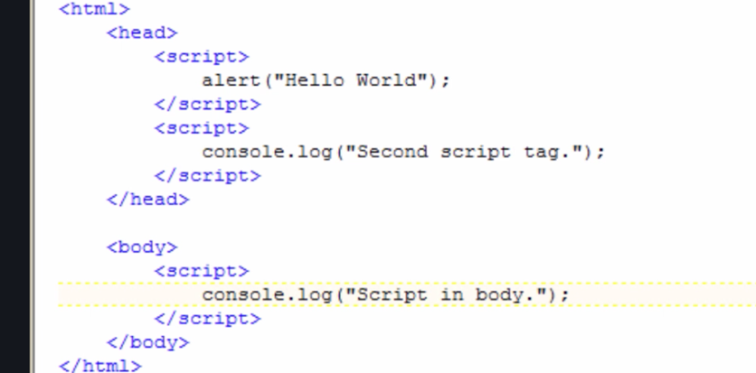

The above picture also shows that the browser will start to execute from head to tail since the html file has multiple script tags. So, the first script tag is executed later the other.

Benefits of external JS (Linking JS files to a HTML)

- External libraries like jQuery, angular JS etc. can be used

- Code can be better organized and reused.

- Intellectual property (not readily available to anyone).

- Cached by browser (Browsers download JS file from servers and stores them in client system)

*Use relative paths in “src” attribute of html “<script> or <link>”tag to avoid directory issues.

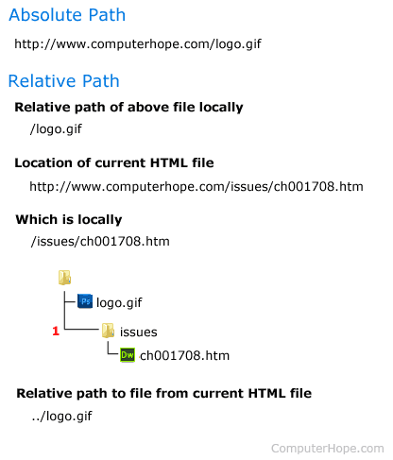

*Don’t use the http or https literals in “src” since there might arise a problem when the html code communicates with the source. If in case the link is supported by http convention but the source as https literal, then warnings or errors may populate. So, it’s better put links like below,



*Its better to follow below convention to avoid errors.

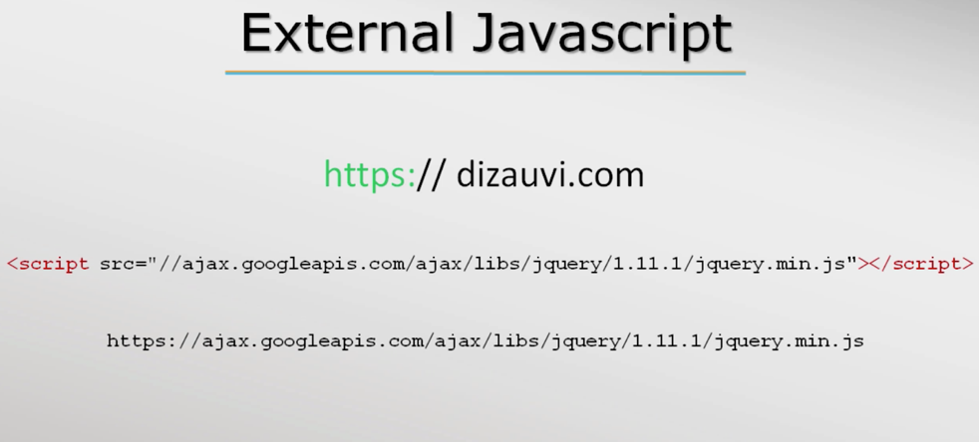

Objects & Array

Objects

Objects in JavaScript may be defined as an unordered collection of related data, of primitive or reference types, in the form of “key: value” pairs. These keys can be variables or functions and are called properties and methods, respectively, in the context of an object

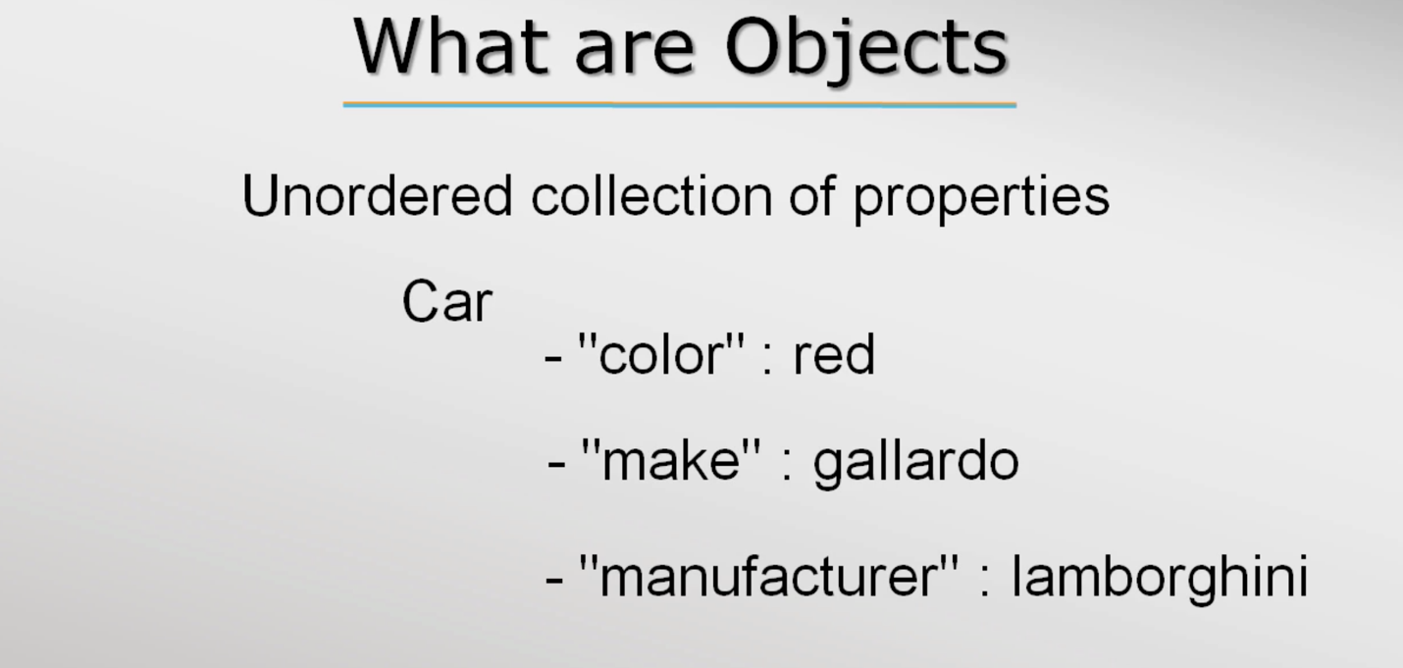

- Car is the object and that has the above properties.

- “color” 🡪 property name and they must be a string but it is not necessary to put them in double quotes.

- red is a value for the property “color”.

Ex: Object usage in JS.

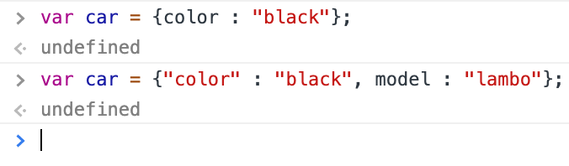

*Same kind of object structure is followed by Python.

Ex: Initializing empty objects with no properties.

>var car = {}; // car is an object initialized with no properties

<undefined

>car;

<Object {} // var car belongs to object data type

Ex: Initializing objects with new keyword without properties and later properties are added using dot (.) operator.

>var car = new Object(); // var car is initialized with new object

<undefined

>car;// car is empty object

<Object {}

>car.color = “black”; // adding properties to the object

<“red”

>car;

<car = {color : “black”}

Ex: Initializing empty object using the method create().

> var car = Object.create(null); // create takes argument so pass null to create an empty object

<undefined

>car;

<{}

- JS is a prototype-based OOP language, not a class based, so objects itself an instance and instances can be created for the object.

*Difference between instantiation and initialization: Instantiation refers to the allocation of memory to create an instance of a class whereas initialization refers to naming that instance by assigning the variable name to that instance.

Object properties

- Properties of objects can be accessed using (.) dot operator as well as the using associative array.

Ex: Accessing Object using associative array method.

>var book = new Object();

<undefined

> book[“title”] = “Cracking coding interview”; // write

< “Cracking coding interview”

>console.log(book[“title”]); // read

- Deleting a property is pretty simple just access the property and use the keywork delete.

Ex: Deleting an property.

>delete book.title; // deletes the property title

<true

>book;

<{} // empty object

- To iterate over object properties in JS, for/in loop is used.

Syntax: for/in loop

for (var x in book)

{

// code block

}

Ex: for/in loop

>var book = Object.create(null);

<undefined

>book;

<{}

>book.title = “Cracking the coding interview”;

<“Cracking the coding interview”

>book.author = “Gayle Laakmann Mcdowell”;

<“Gayle Laakmann Mcdowell”

>book;

<{ title: “Cracking the coding interview”, author: “Gayle Laakmann Mcdowell” }

>for (var print in book) { Console.log(print + “ - ” + book[print]); }

title – Cracking the coding interview

author - Gayle Laakmann Mcdowell

> |

- Normal empty object has additional properties which comes from object prototype.

Ex: Console shows inbuilt properties of the object Animal.

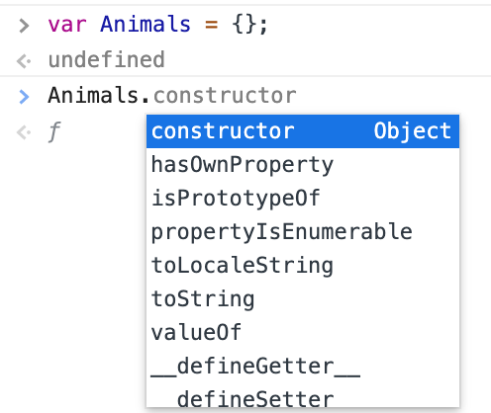

---------------------------------------------------------------------------------------------------------------------

JSON – Java Script Object Notation

- JSON is a very popular data format that represents data as strings and it is sent between client and server.

- JSON data format is more readable so it is primitively used over its competitor XML.

- JSON data is represented similar to Objects representation in JS but both are different. Where Objects accepts ‘’ while JSON doesn’t accept single quotes ‘’.

*JSONLint is an open source project which allows you to validate your JSON data. Since when you are working with any programming language and JSON, if your JSON data is not properly formatted, it can cause error, it is better to validate your JSON data beforehand.

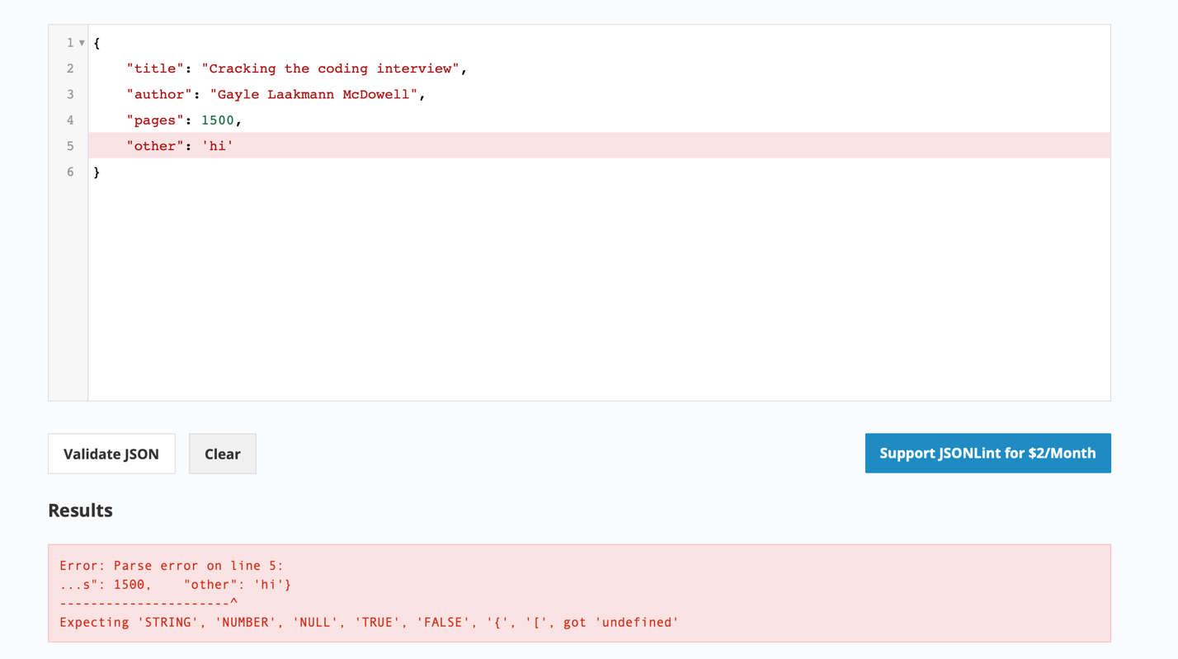

Converting var book_as_string – string literals which is in JSON format to Objects using JSON.pasre() method

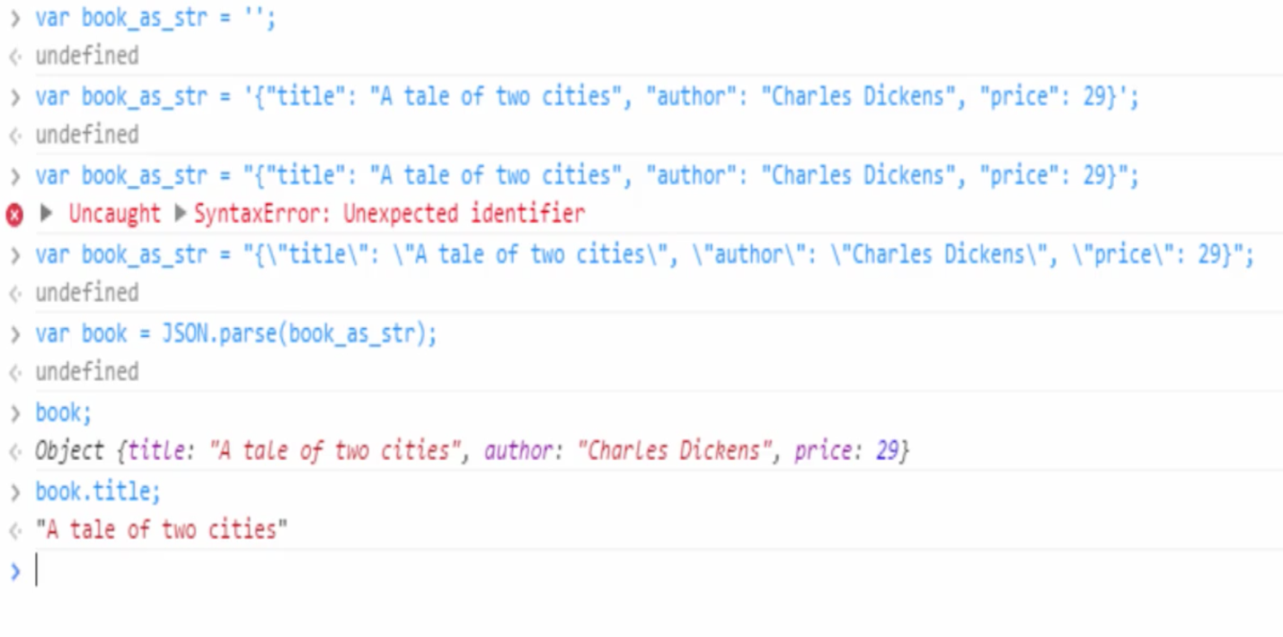

*

- XML are really a big deal to parse data in JS. And this is why exactly JSON’s are prominent.

- JS objects can also be converted to JSON

* The default conversion from an object to string is "[object Object]"

- What is the output of the following code snippet?

>({title : "The Three Musketeers", author: "Alexandre Dumas", price: "$49"}).toString()

<[object Object]

Global Object

- Like other programming languages JS also links functions but it happens quite different here.

- JS has no linker but has globalThis object, which ties everything together.

- In the browser environment globalThis is the window object, so when the new pages load up JS interpreter starts and creates a new window and put all properties.

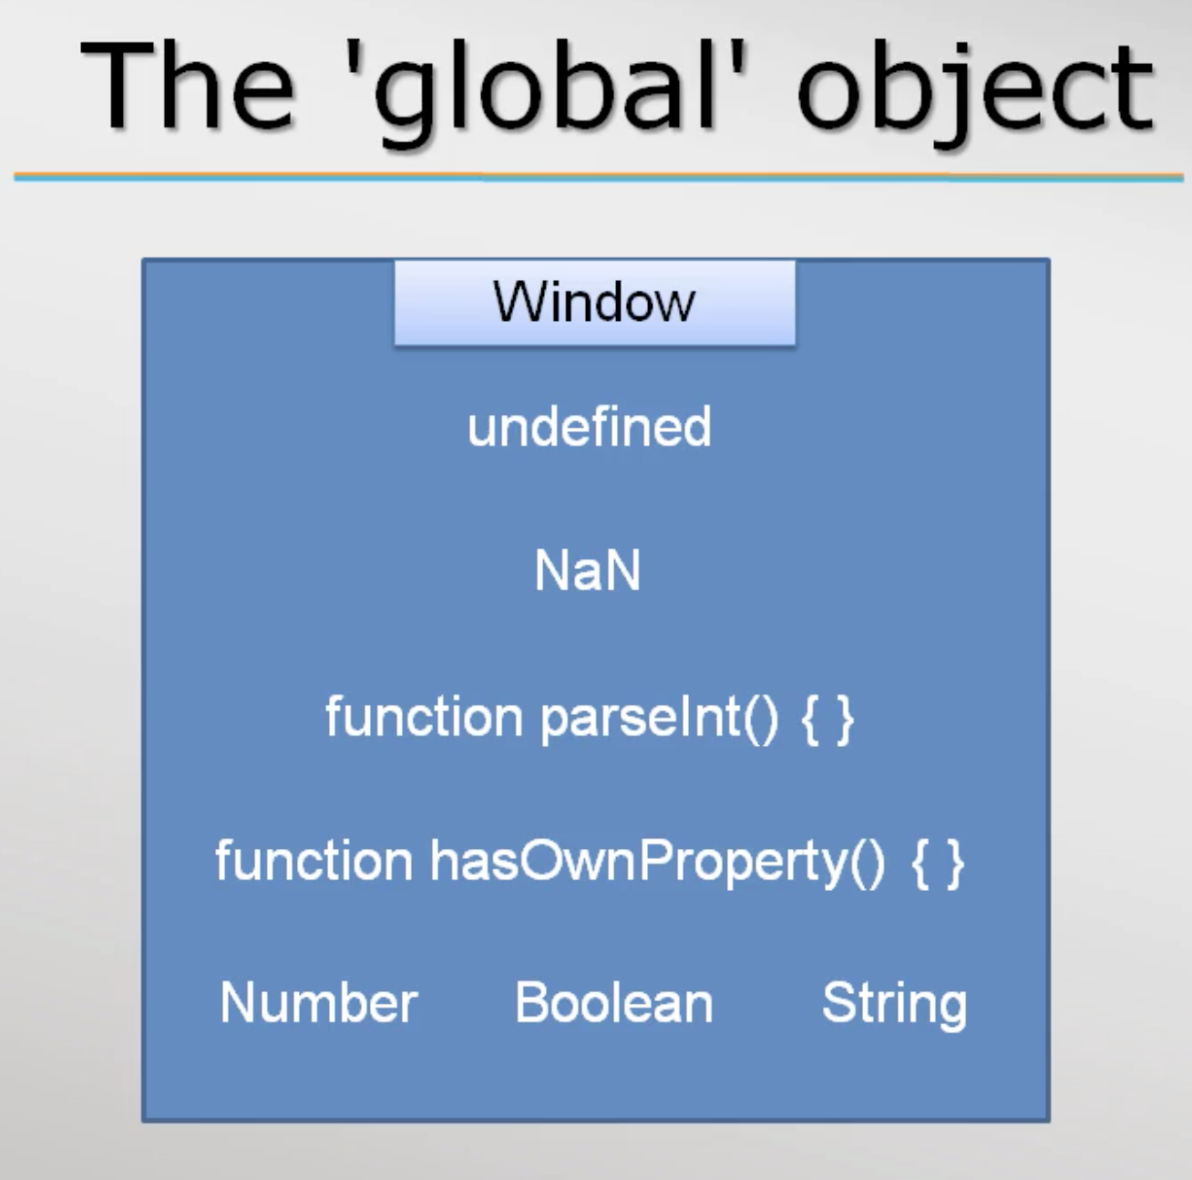

- JS interpreter always has a globalThis object but in case of a browser globalThis is called Window.

Both are same 🡪

>global === window

<true

- the variable, functions and objects which is created will become part of Window object.

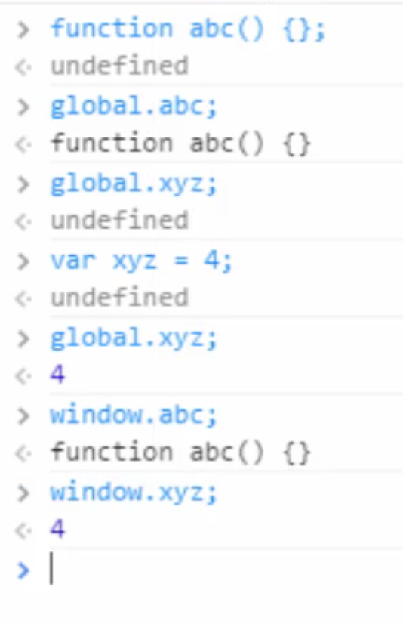

Arrays in JS

General definition of an array: Array is basically a data structure or container object that holds a fixed number of items of specific types. Memory layout of an array is contiguous

But in JS Arrays don’t follow their general nature.

- They can be initialized with zero element.

- items can be added to the array later. That is it grows dynamically.

- obviously they don’t have a data type. Hence we can store any type of element.

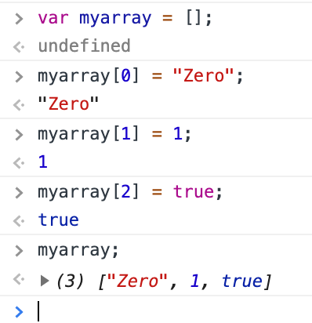

Sparse(scattered) Array

In JS we can load values to any index without error and warnings.

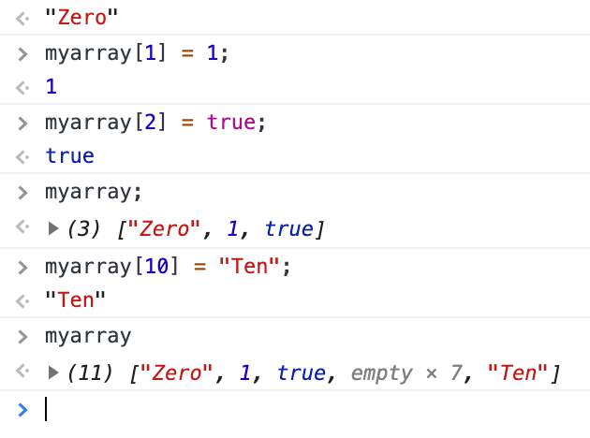

In other programming languages array elements should be adjacent to each other. But JS overrules the traditional rule.

Array as objects

- The reason why arrays are so convenient in JS is because they don’t have any underlying data structure. They use objects has their data structure.

- Arrays work like this🡪 Array indices are converted to strings and these strings will hold values. Exactly like properties in object, where properties are strings. can hold. Hence JS just makes up array but in fundamentally it is an object.

The below code snippet shows array as objects,

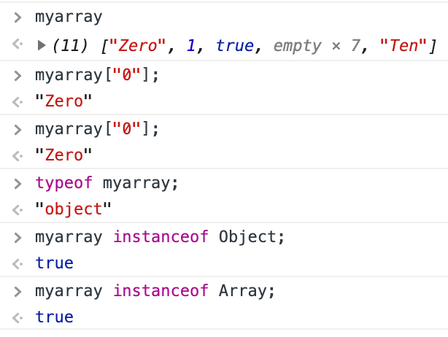

Array is a function but remember a function can also be an Object in JS.

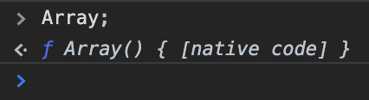

Here the myarray takes a string as indices but still add the values to it.

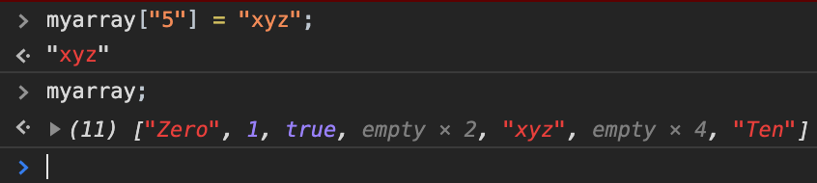

Length of an array

- As previously mentioned, array is an object in JS. So it has predefined properties. Length is one such property of array object. Length property can be accessed as show below,

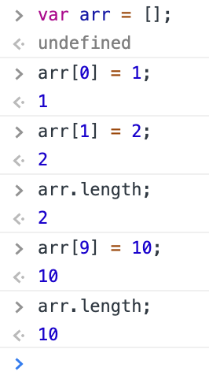

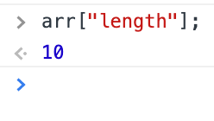

- Since length is a property, we can also use the index notation to print length of the array.

- When iterating an array of 10 elements it shows undefined for 7 which in between the index of 2 and 8. Because as in the previous screenshot it is shown that only 3 indices [0,1 & 9] of array were assigned rest were left empty. So the console throws undefined for the 7 elements and pints the value for rest.

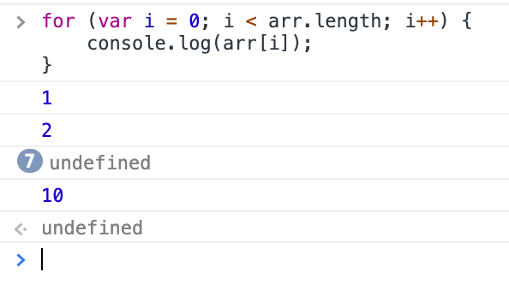

- Since length is a property, we can also set value to it. Like shown below, if we set less value to length property though it’s length is beyond the assigning value. It will still accept the value and will truncates.

The length property can be dynamically change when we assign new value to different indices.

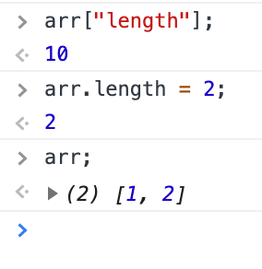

Iterating over an array

For loop can be used to iterate over an array. What if we want to iterate only the valid elements. In the screenshot below for loop iterates all elements including the undefined, which are not assigned.



The below condition can be used to avoid undefined,

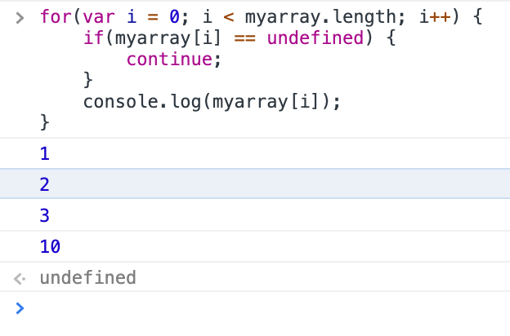

Or we can also use for/in loop, that access each property of an object. For/in loop leaves out undefined property.

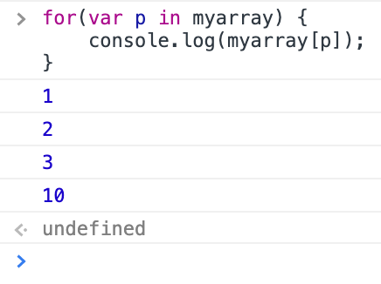

- but for/in loop is not recommended to use because JS may add property to array object and it might print. So the best way is to use “hasOwnProperty” property like below,

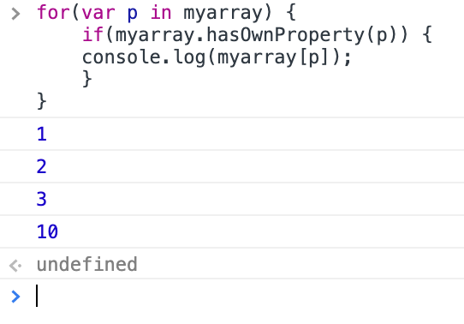

Deleting elements of an array

- Simply use delete key word and mention the index of the element to delete. Array length will not be affected, JS just assigns the deleted element to undefined.

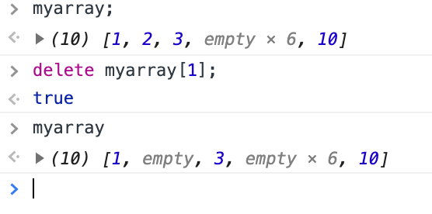

- if we want to shrink the length of the array element when deleting an element, splice method should be used

Methods in an array

- concat

- join

- push and pop

- splice

- slice

- sort are some basic methods in array object.

- concat(): used to join 2 or more array into one.

Ex:

>var a = [1,2,3];

<undefined

> var b = [4,5,6];

<undefined

>var c = a.contact(b); //concat method takes array as argument

<undefined

>c;

<(6) [1,2,3,4,5,6]

>var d = a.concat(b,c);

<undefined

>d;

<(12) [1,2,3,4,5,6,1,2,3,4,5,6]

- join(): gives the string representation of an array with a separator. The default separator is “,” but we can give any thing we want.

Ex:

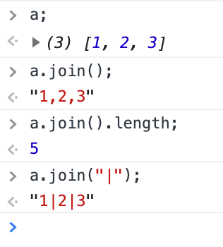

- push(): add new element at the end of the array and returns length of the array. Similar to push unshift() is a method that add elements at the start of the array.

Ex:

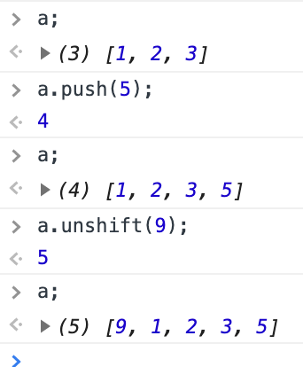

- pop(): is used to remove the last item and returns the element of removed. Shift() is used to remove the first element of the array and returns the item removed.

Ex:

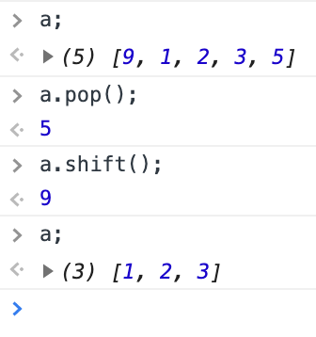

- slice(): slice returns a new array object without affecting the old array. And it takes at most of 2 arguments, the first one is the start index and second one is the end index.

Ex:

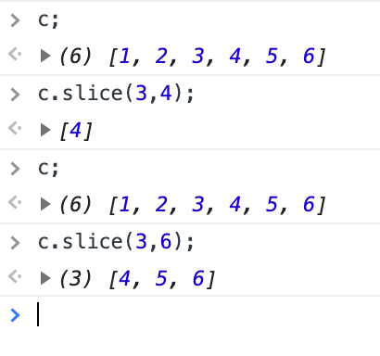

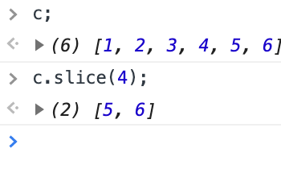

- splice(): splice returns a new array object of spliced element from the old array and also splices up the old array. It take 2 arguments like slice. The first arguments denotes where the index starts while the second shows the number of elements to be removed after the start index.

Ex:

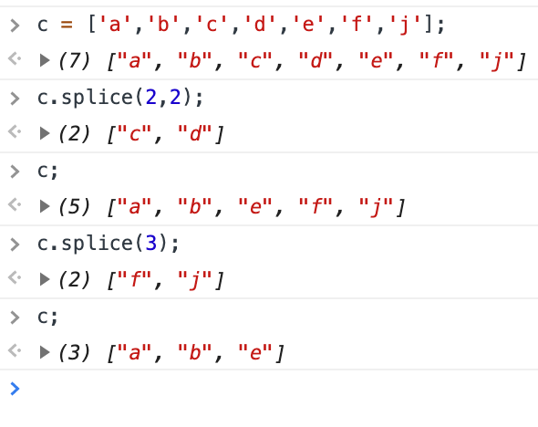

After the 2nd argument it can still take arguments, but they are used to replace the element of old array.

Ex:

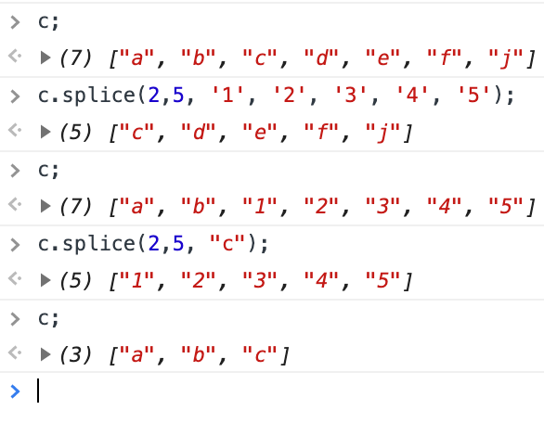

- sort(): will sort the array in ascending alphabet order or lexica graphical or dictionary order.

Ex: this is how the array sorts,

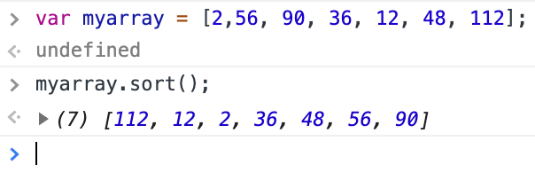

To sort array properly we should use a function and the below is the algorithm of the function should work

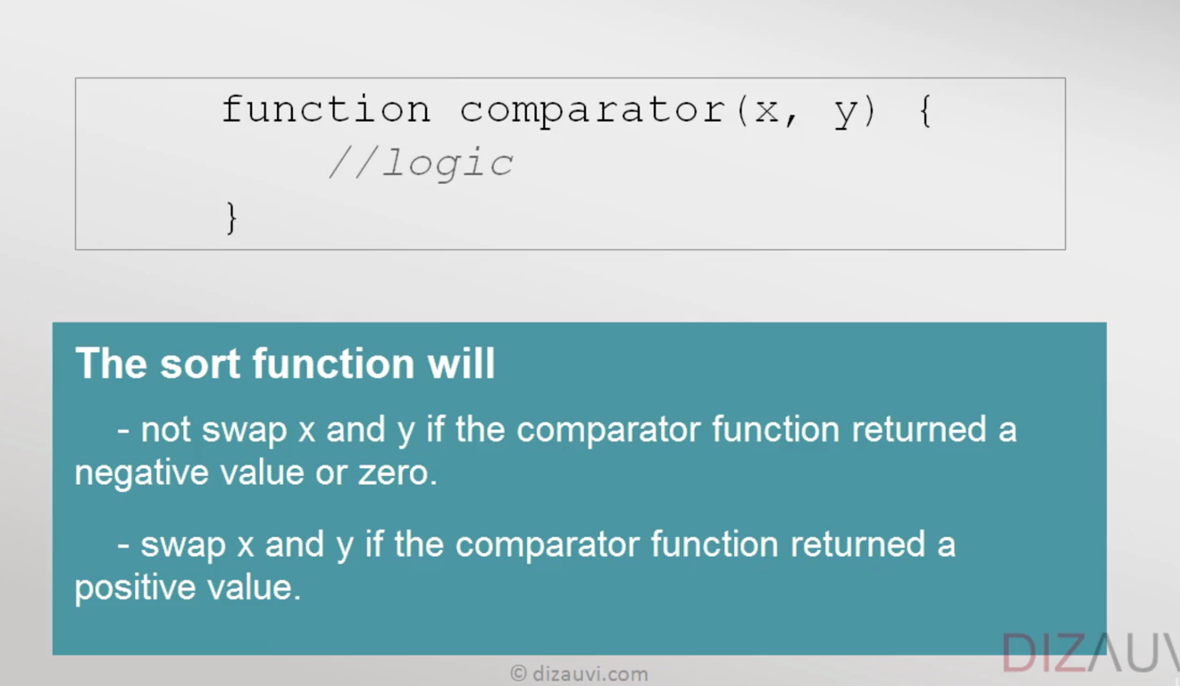

function num_comparator (a,b) {

return (a-b);

}

*no use of parenthesis if a function is not invoked

Ex: the below sorting happened in ascending order

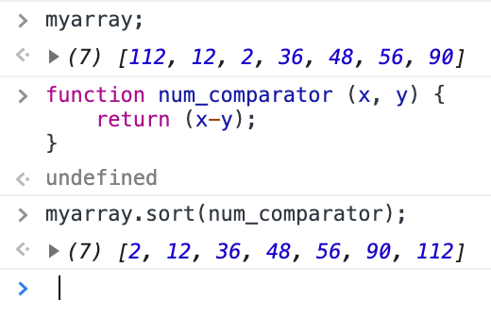

Ex if the sorting to be happened in descending order, just return b-a.

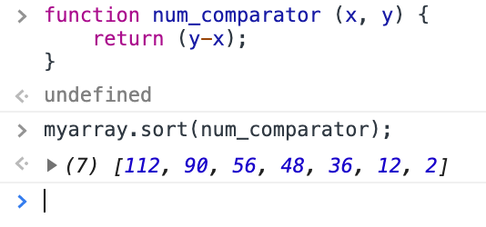

So the sort function only check +,- or 0 of the number returns from the function num_comparator(). And depends on that it sorts.

*idea of passing function as arguments comes under functional programming

Functional programming

Programming Paradigms(patterns)

- Procedural - c

- Object oriented – c++ & java

- Functional - Haskell

And Hybrid (a mixture of above) - JS

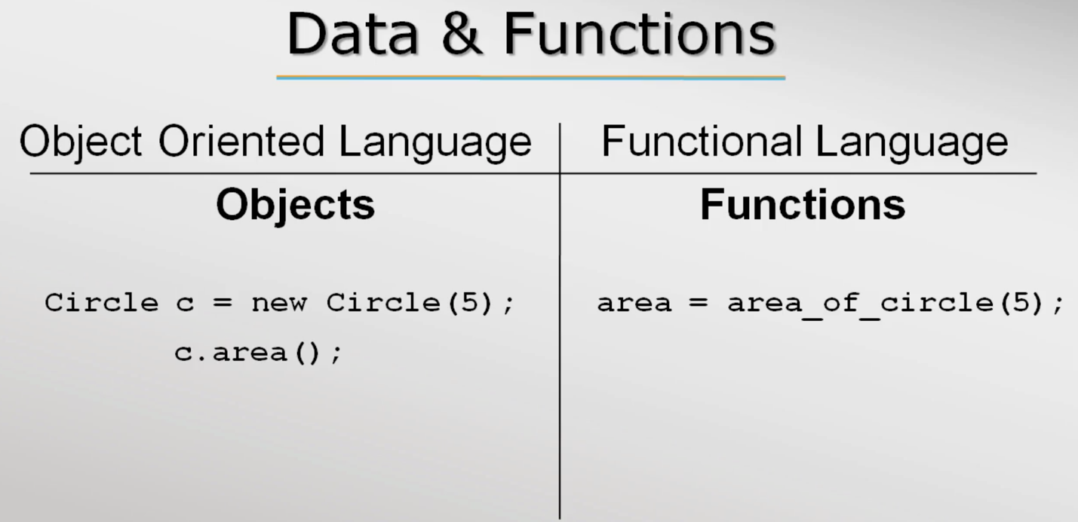

*In the above screenshot the object is created by for the class circle by calling a constructor of the class. This is followed in Java. Whereas, in C++ just object is created without the constructor call. it is implicitly called when the compiler finds the object of the class.

*people always think procedural and functional are same, but they aren’t. In procedural language we can’t store a function in a variable but in functional language we can do that. Since in functional language there is no difference between function and data. Functions are just like objects. 🡺 In JavaScript, functions are first-class objects, because they can have properties and methods just like any other object. What distinguishes them from other objects is that functions can be called. In brief, they are Function objects

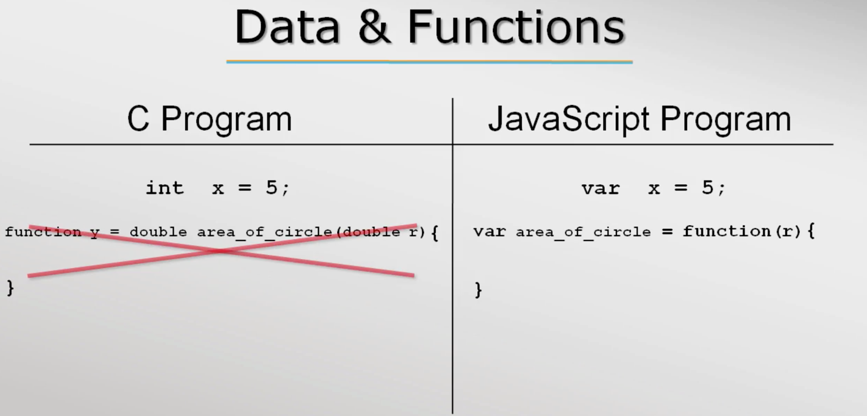

In the example below, you can see that JS treats abc as a variable we can append a value to it and JS takes it as string. But we can also use it as a function and at this time when I append a value it adds.

The forms, function abc() { return 5; } 🡸🡺 var abc = function () { return 5; }

That’s why when I append a value to abc it includes it and gives a string. But if I use the abc as function it will return 5 and appended to the given value. abc() + 6 🡺 11

*So to remember data and function are pretty much treated same

Haskell – data is said to be zero order function and functions are said to be higher order functions 🡪 both are passed as arguments

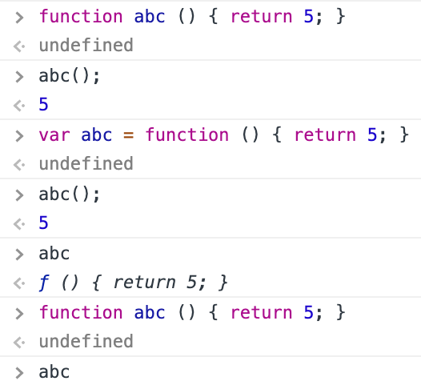

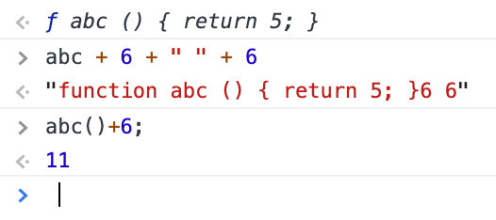

In the above var abc = function () { return 5; } is a anonymous function declaration.

Higher order functions

– functions are passed as arguments since in functional programming functions are considered data

- definition “A function that either takes a function(s) as arguments or return a function” 🡨

🡪 h(x) = f((g(x))

Understanding functions as argument by num_printer example.

- lets create a function that prints 1 to max numbers “num_printer(upto)” typically we will pass a number “upto’as argument to the function print_num(upto) which will print a list of number like this, num_printer(10) 🡪 1 2 3 4 5 6 7 8 9 10.

- what if I need to print odd or even number. mostly what programmers do is write another function which prints odd and even. It’s worth to write another function. In reality it consumes time and effort. So it better to abstract out the changes and pass as argument to the existing function, in this case “num_printer(upto)”, and tell this function to perform required task like print even, print odd or print prime. So this is where functional programming comes to play.

- for the example function we can pass a filter function which will odd out the number.

Ex: function prints max number and takes “upto” as parameter, which will pass number as argument.

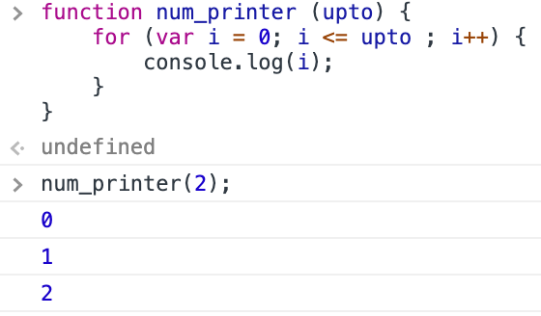

Ex: adding an parameter “filter” to the existing function, where we will pass a function as argument.

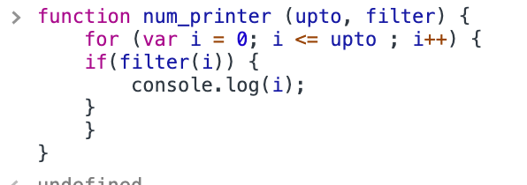

Ex: a separate function that check odd or not and returns boolean is created

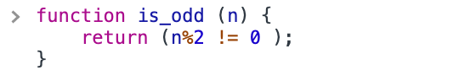

Ex: this is_odd function is passed as argument

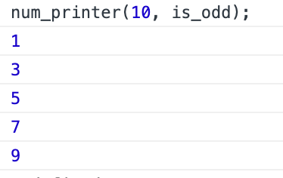

Ex: if I need to print even number means I have to pass another function “is_even” as argument that will return true to the num printer in turn It prints even numbers or if I need to print all number I have to make the if condition true so I need to create a function that returns true.

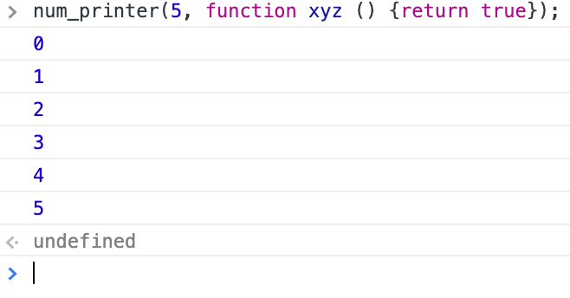

Anonymous function

- Function is JS can be written without function names and they are called anonymous functions

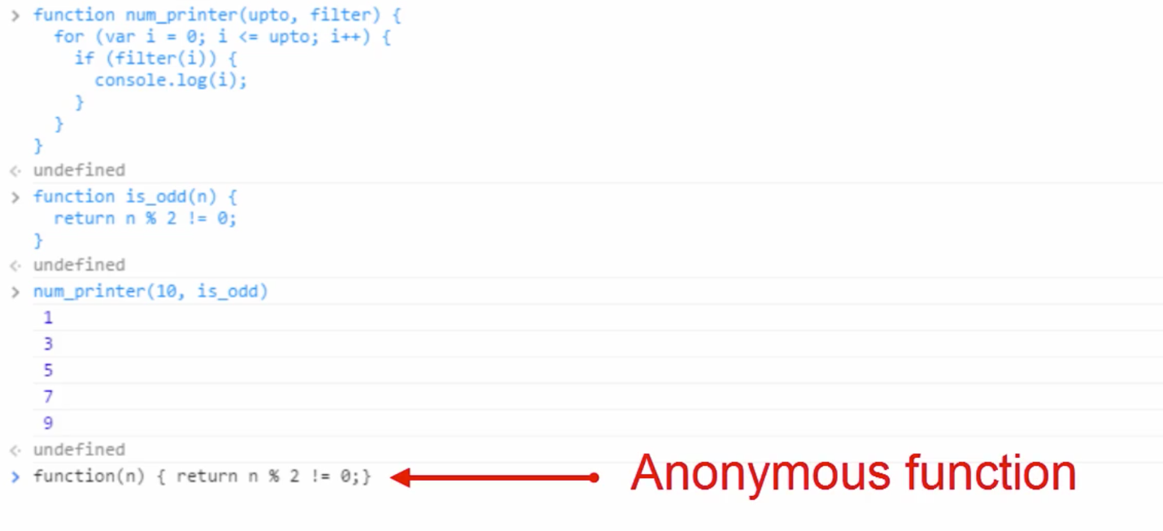

- if we are not giving a name for such function we can’t use it late.

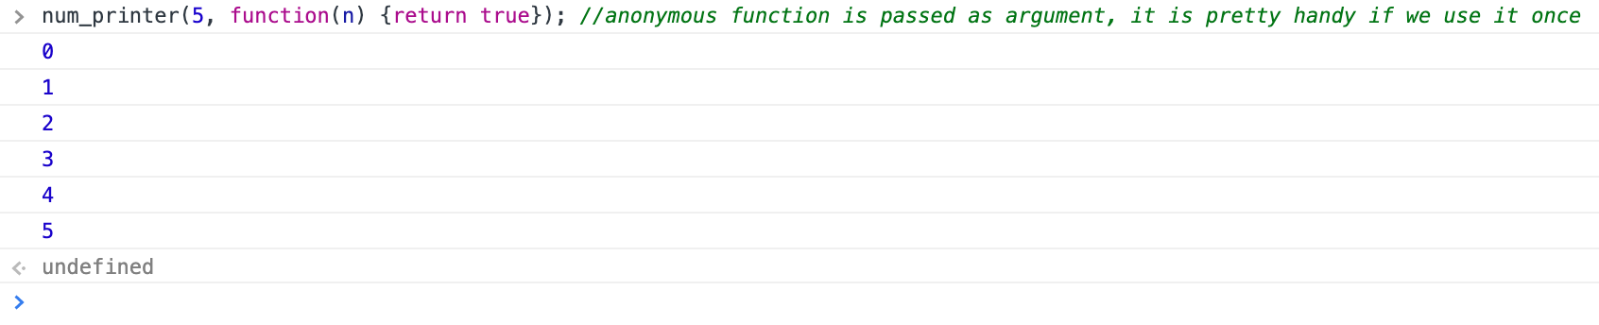

*forEach() is a function that works with array. And it takes function as argument.

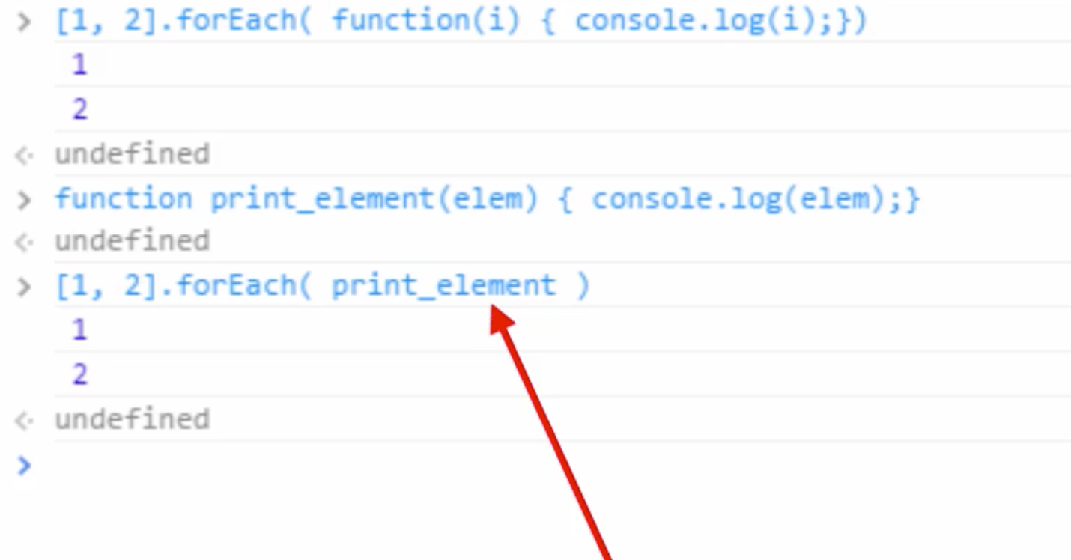

For each function goes to each element of the array and passes the element to this argument, which in turn logged the element.

Nested functions

- function inside another function

- nested function follows functional scope

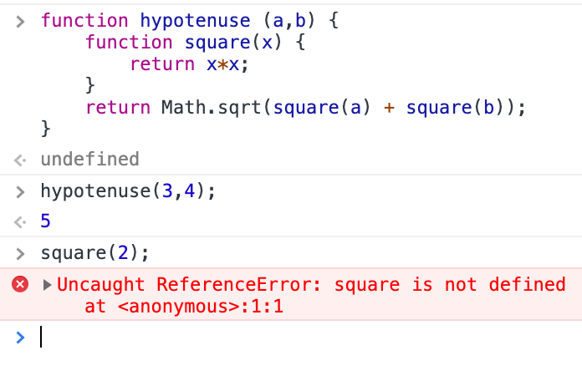

Here I can call hypotenuse function but can’t call square because it is nested. This is applicable to variable.

Closure

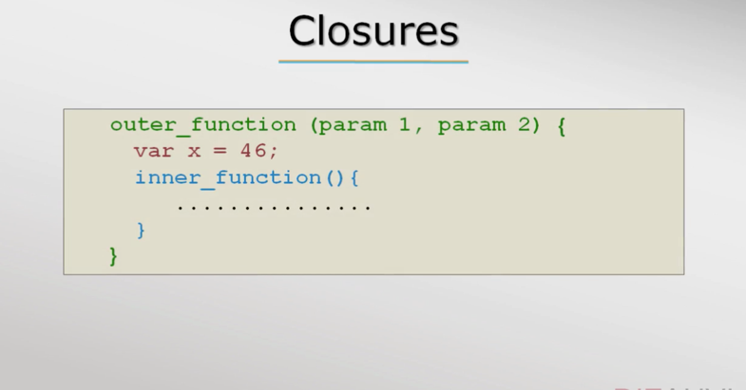

- even when the outer function goes out of scope and the parameters passed to the outer function will be available to the inner function because after all parameters to a function are local variables.

- closure are available in all functional programming language

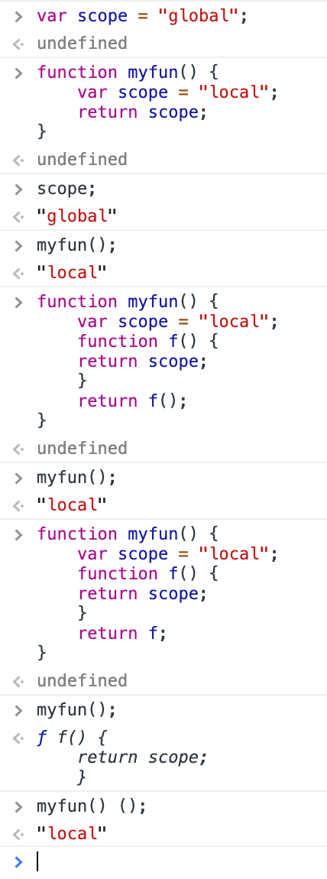

- if no var is loaded inside the function then it checkes global variable

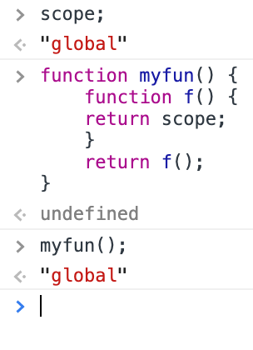

Close example

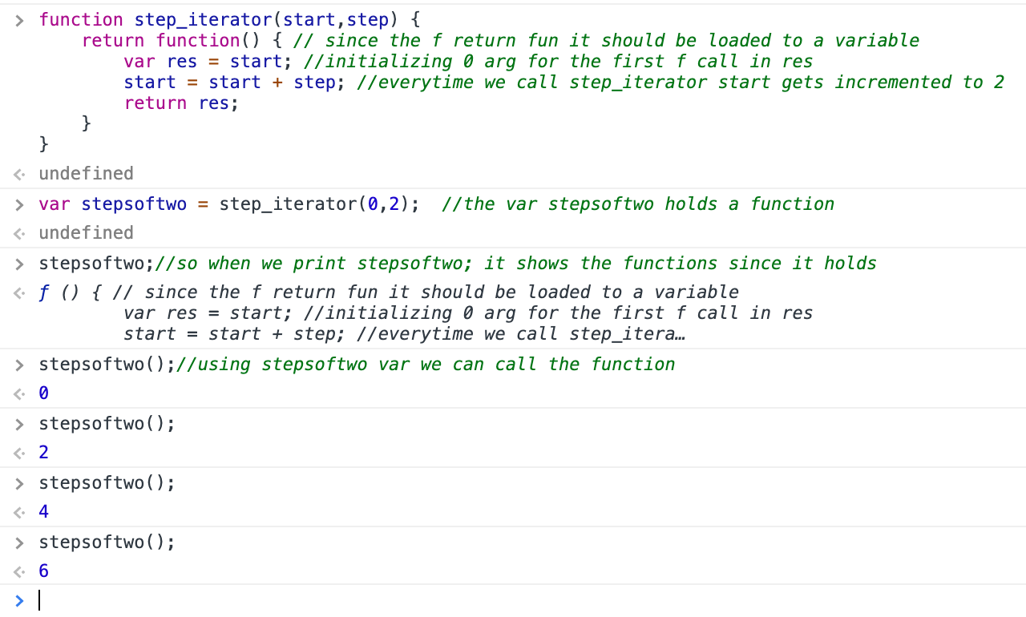

- if we load the same fun in another variable It will start from 0 step

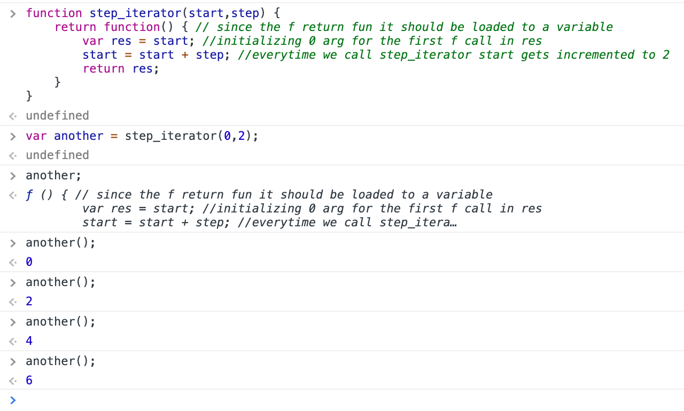

List comprehension

- in many programming languages collection of data or set of data is called as list.

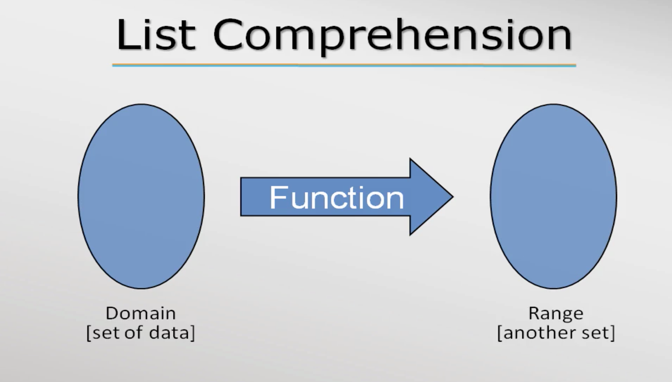

- JS supports 3 list functions,

- filter

- map

- reduce

- List comprehension is basically a feature provided by programming languages to ease the work of developers.

- these list comprehension works on array

- filter function

[2,4,5,6,12,15] 🡺filter🡺 [2,4,6,12]

Filter function take another function as argument it can be anonymous or normal functions



- The anonymous function passed as argument in filter() is called callback function

Callback function syntax:

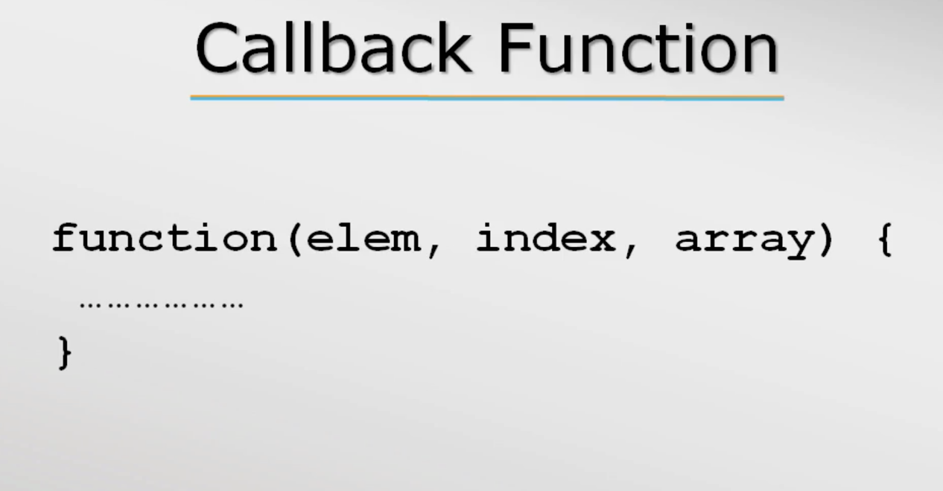

*Callback must return a Boolean value for filter function.

-In call back if only one argument is passed in place of 3 the other 2 are considered as undefined by JS

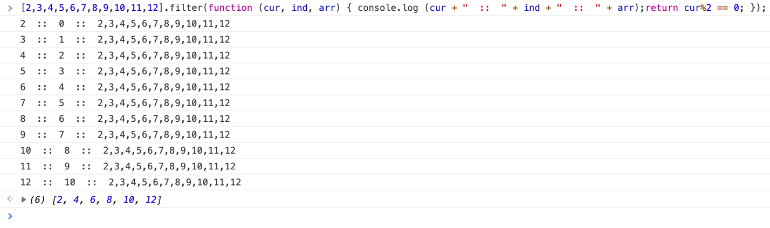

- map function

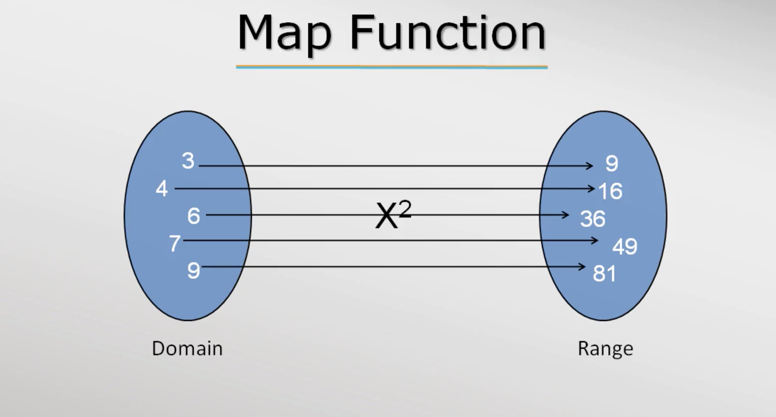

Ex:

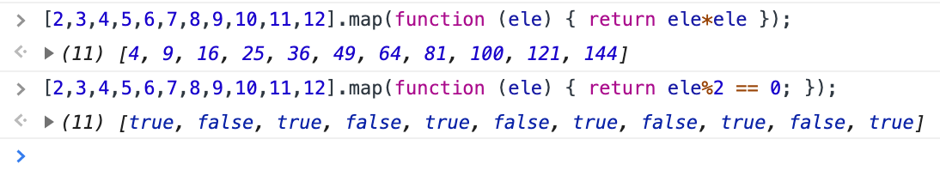

*callback function is similar to filter but it will return a value corresponds to the input.

- reduce function

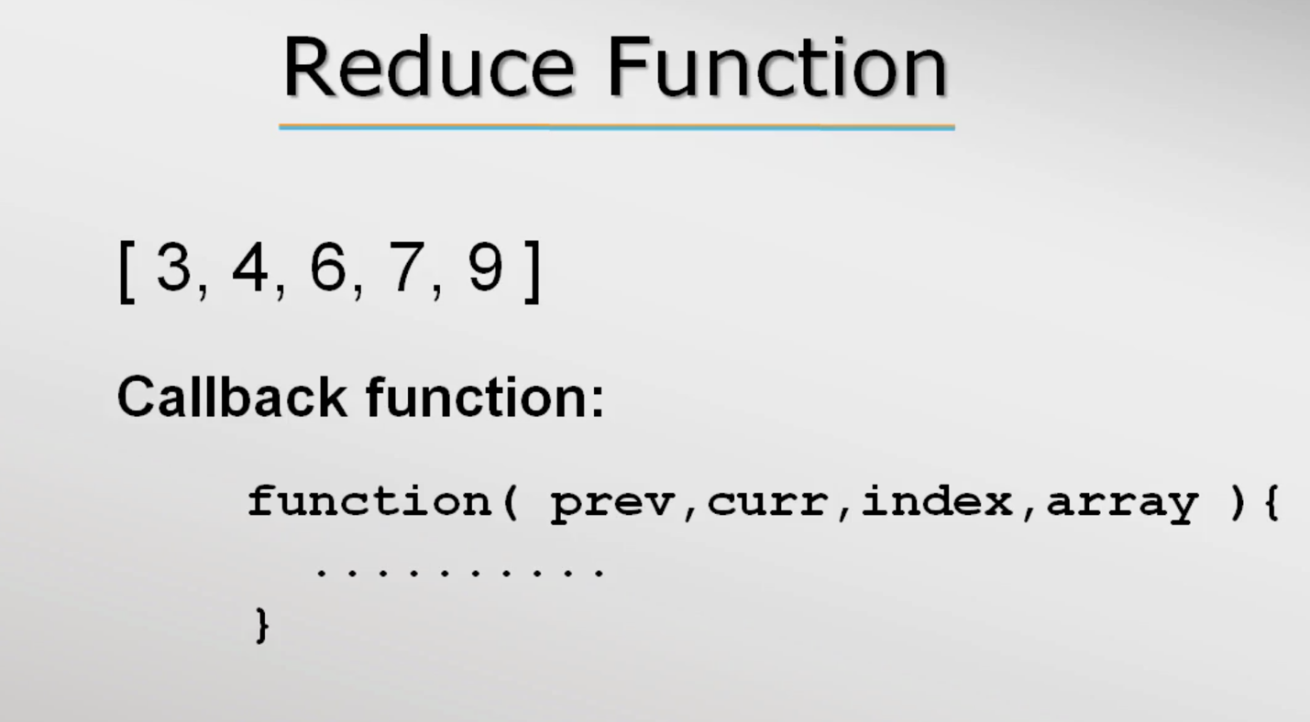

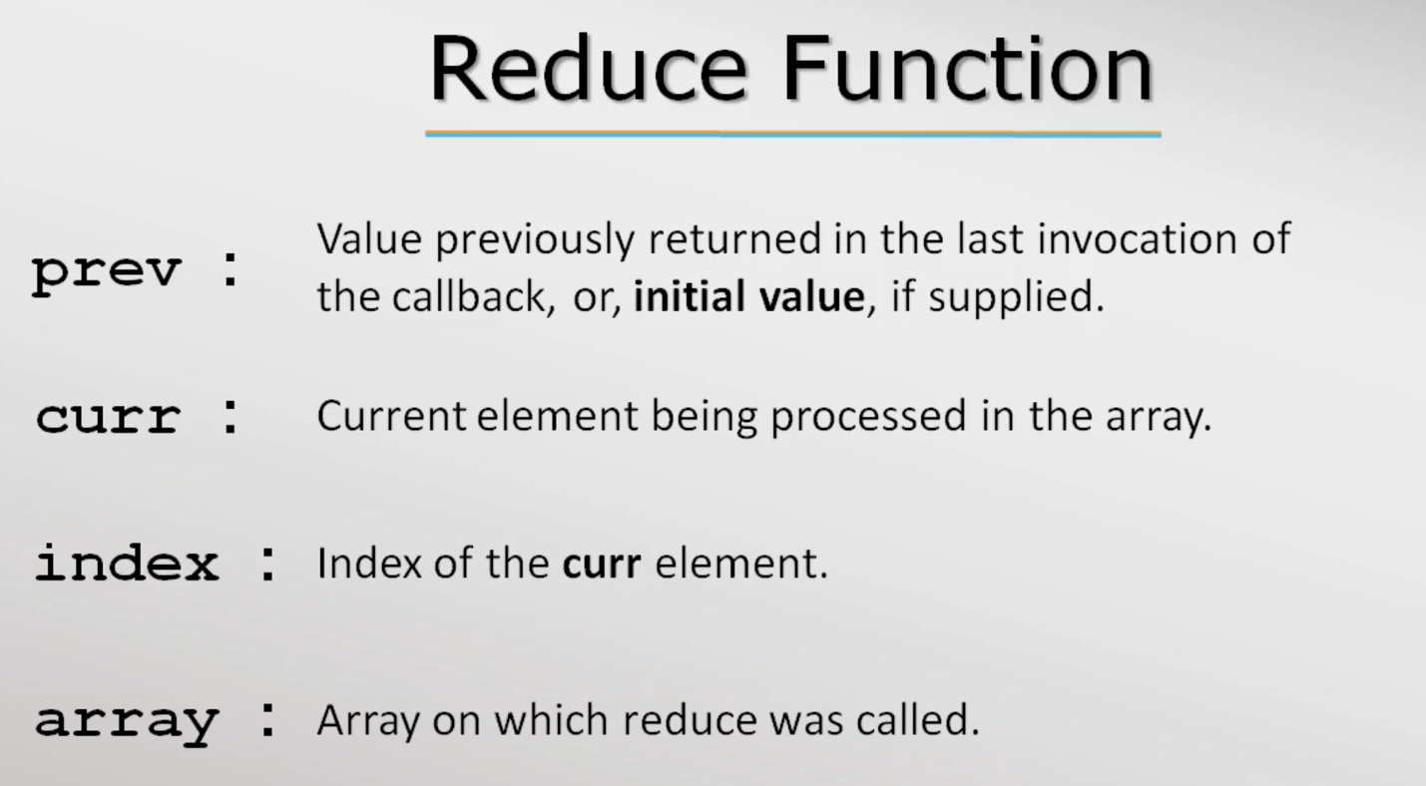

Ex:

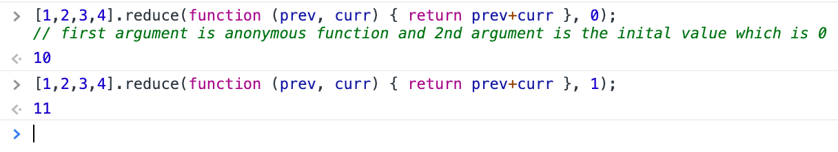

Explanation:

Call 1

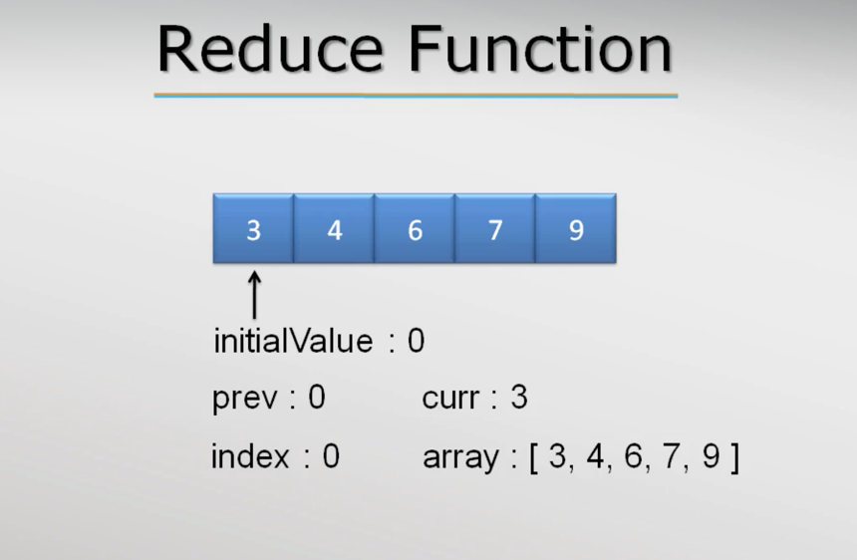

Call 2

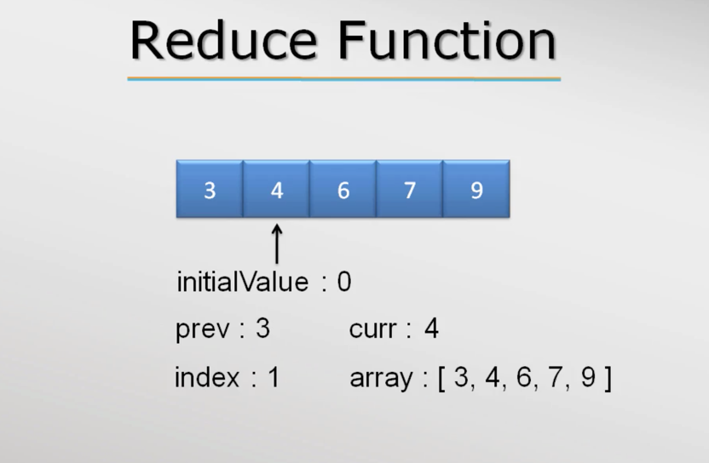

Call goes till it reaches the last ele

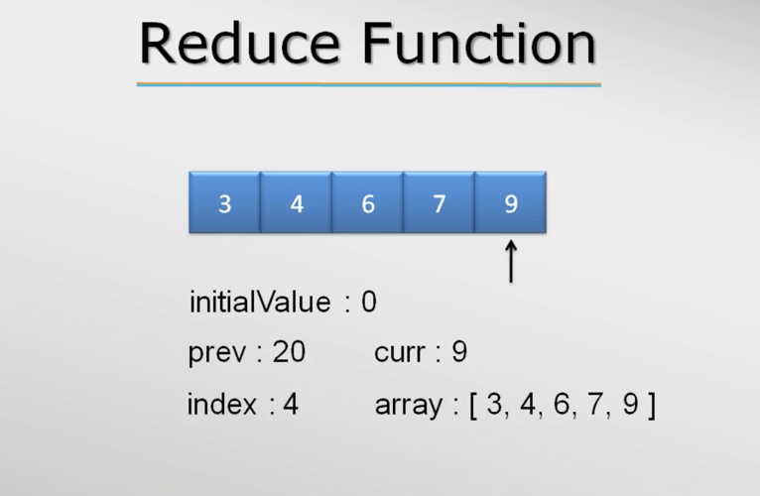

Ex: In the below rest of the arguments were logged

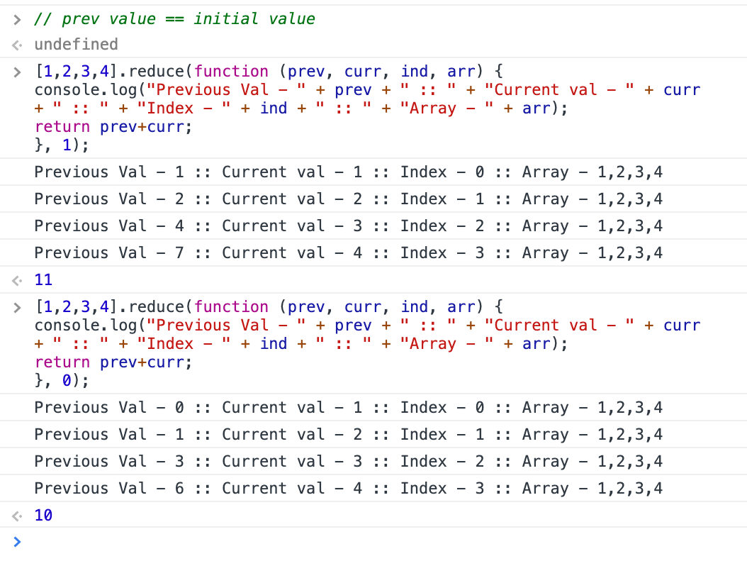

Ex: sum of natural numbers using reduce while the input is number

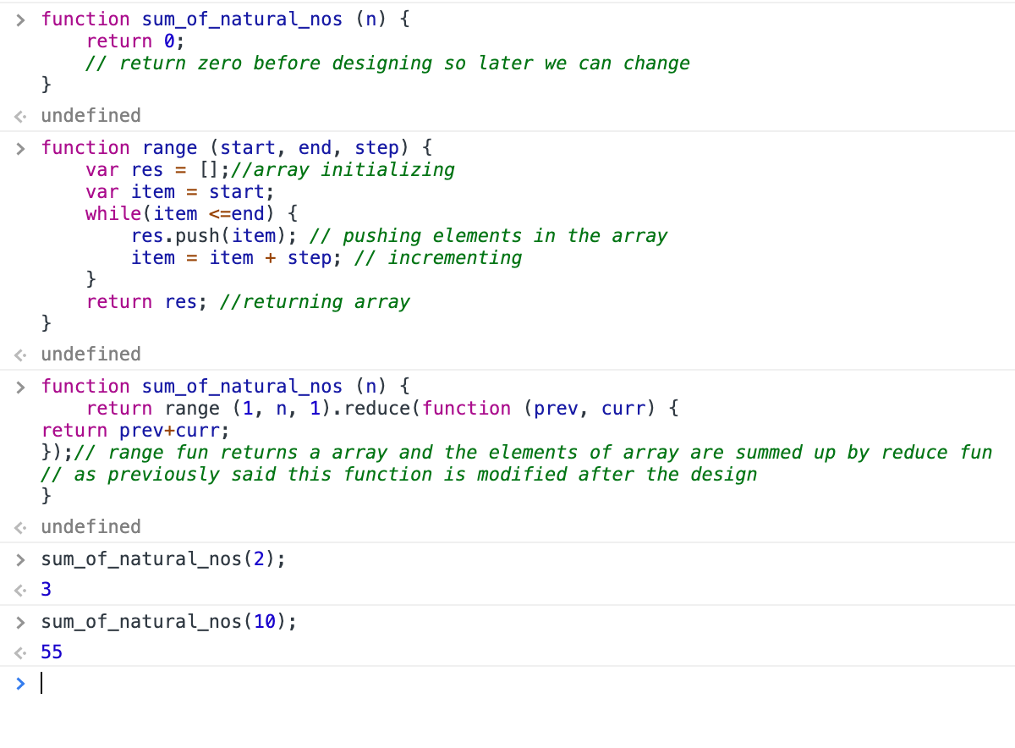

Accessing variable numbers of arguments

- JS has inbuilt arguments object which is array like but not really an array. It will help to get the arguments passed in a functions and list them like array(not exactly array) even if parameters are not defined in the function. But we can’t process the arguments since they aren’t array. The bellow screenshots will give clarity,

Screen shot 1:

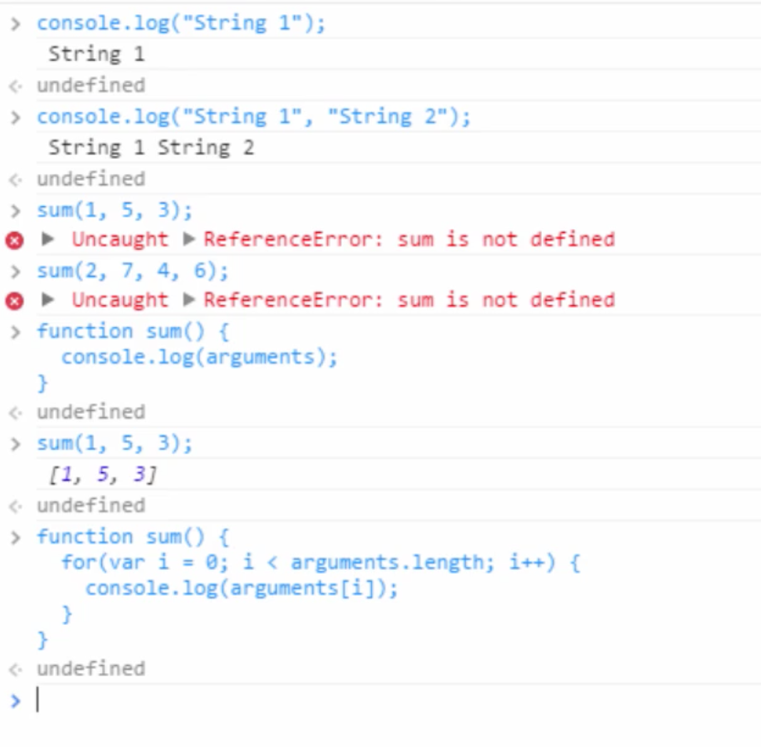

Screenshot2:

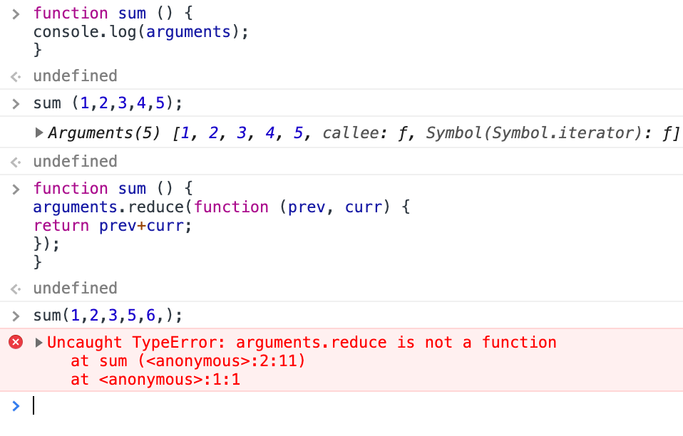

To use the argument as array we need to process it first below some more things we explained so read the comments

